# PROJECT DEVELOPMENT PHASE SPRINT – 3

|  |  |
| --- | --- |
| **DATE** | **17.11.2022** |
| **TEAM ID** | **PNT2022TMID34387** |
| **TITLE** | **RETAIL STORE STOCK INVENTORY ANALYSIS** |

**Year wise stock and price analysis using line graph:**

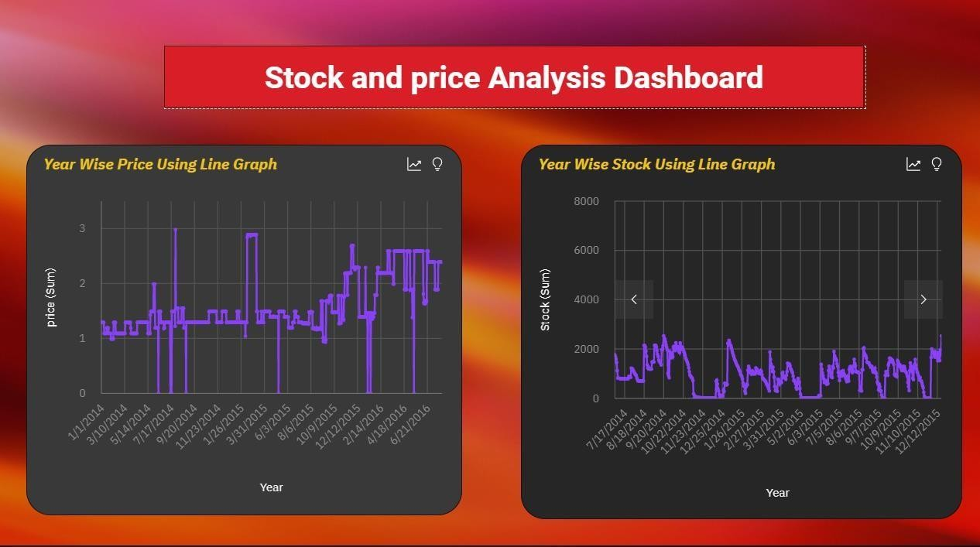

# Top 10 sales and stock using column graph:

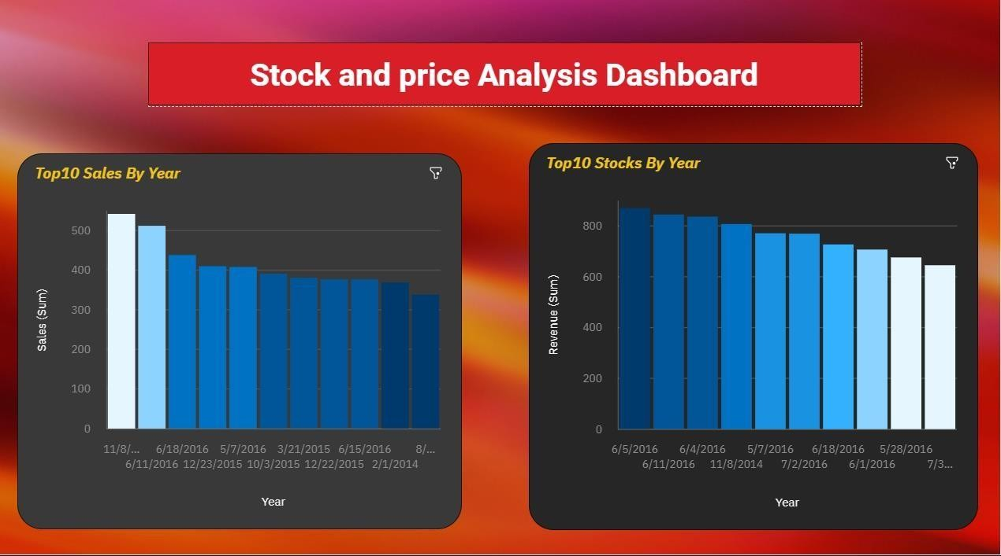

**Monthly wise stock and sales using heat and tree map:**

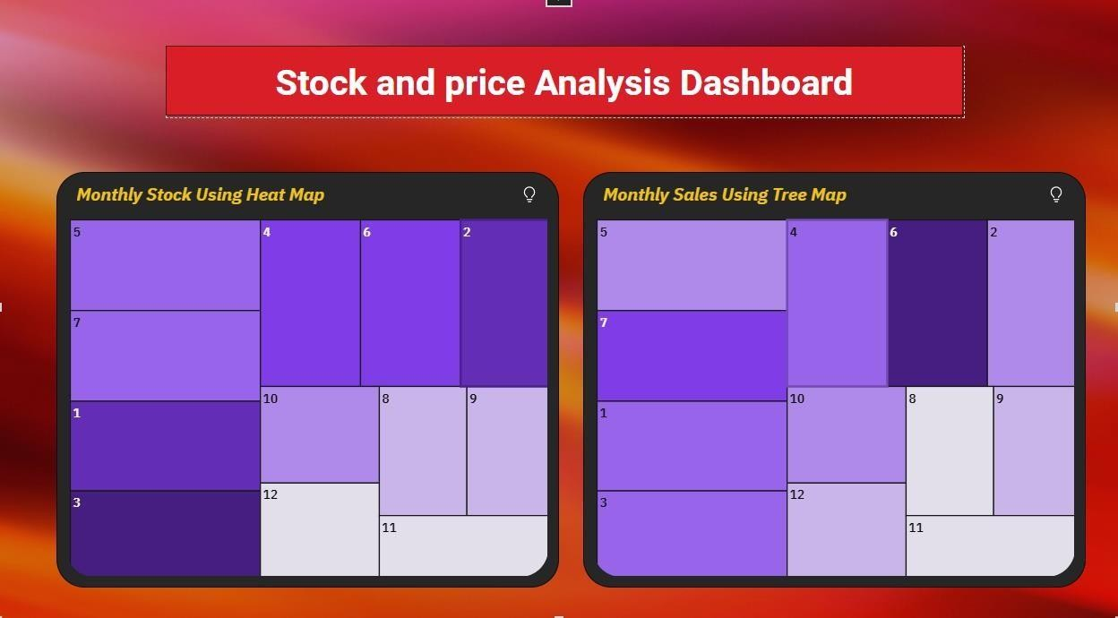

# Monthly and yearly wise revenue using pie chart:

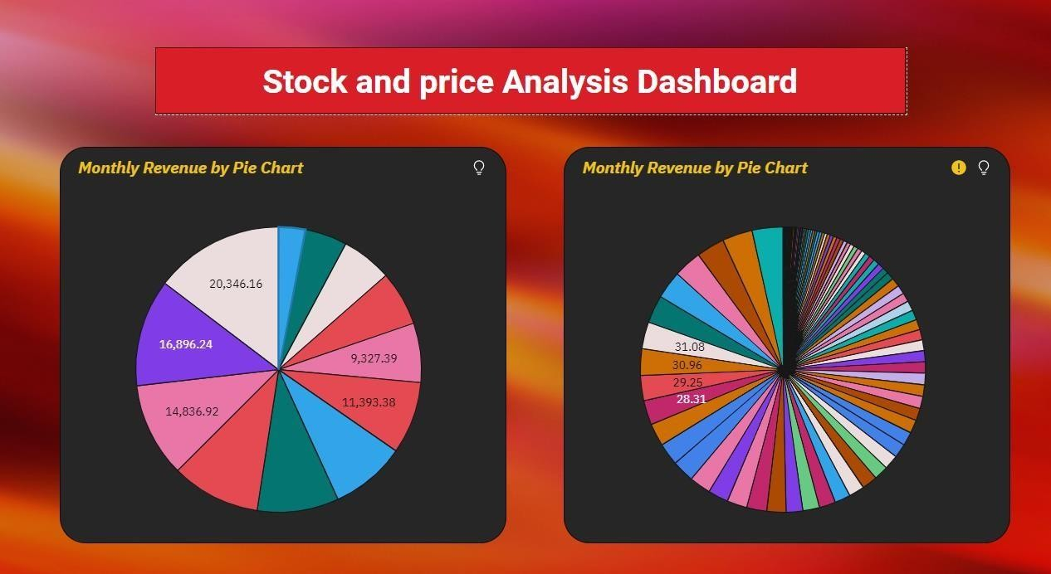

Summary for stock and sales:

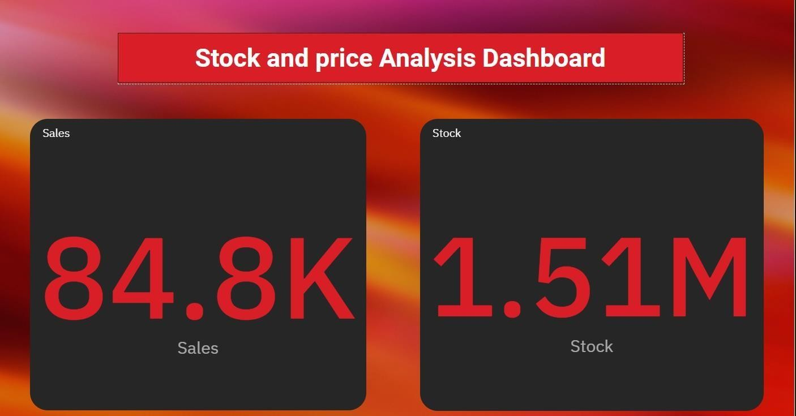

Summary for price using summary graph:

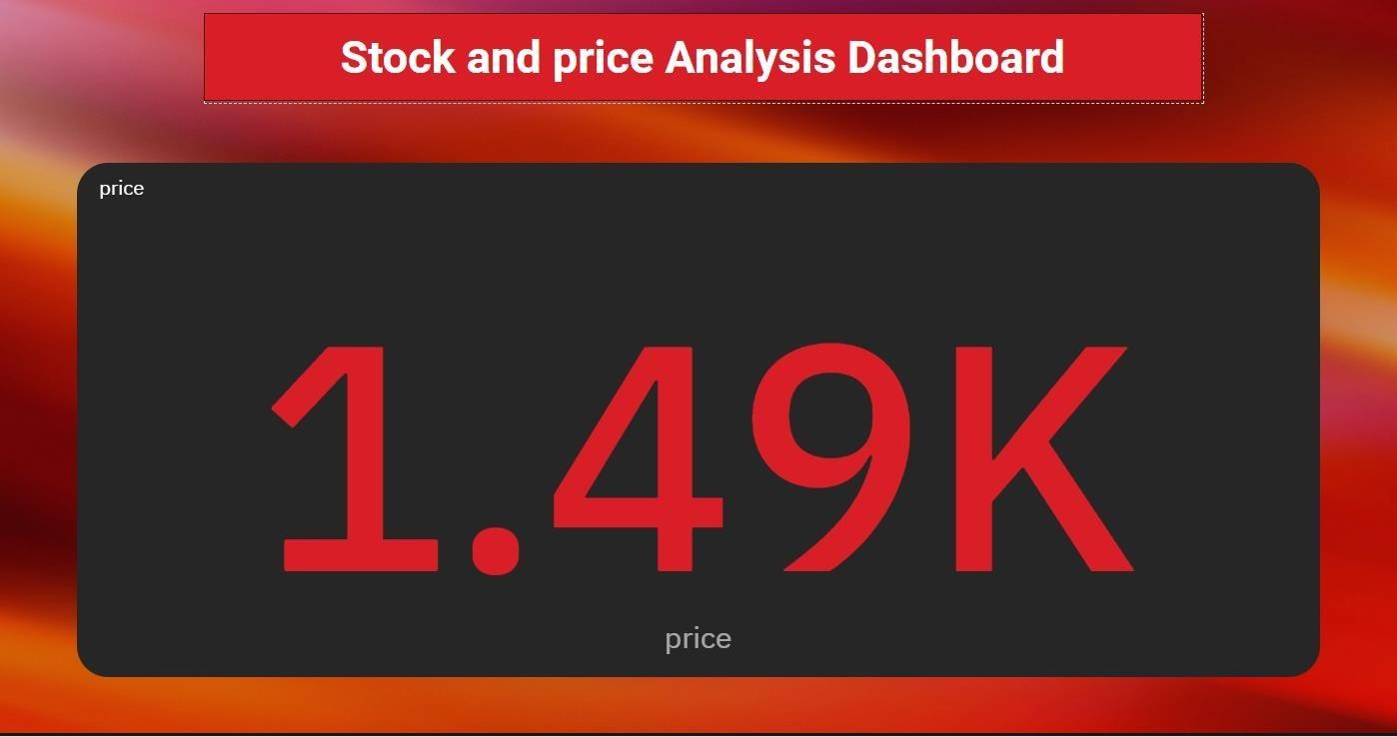

Inventory dashboard link:

[HTTPS://US1.CA.ANALYTICS.IBM.COM/BI/?PERSPECTIV](https://us1.ca.analytics.ibm.com/bi/?perspective=dashboard&pathRef=.my_folders%2Fsprint%2FSprint-3&action=view&mode=dashboard&subView=model0000018456a99a8f_00000007) [E=DASHBOARD&PATHREF=.MY_FOLDERS%2FSPRINT%2F](https://us1.ca.analytics.ibm.com/bi/?perspective=dashboard&pathRef=.my_folders%2Fsprint%2FSprint-3&action=view&mode=dashboard&subView=model0000018456a99a8f_00000007) [SPRINT-](https://us1.ca.analytics.ibm.com/bi/?perspective=dashboard&pathRef=.my_folders%2Fsprint%2FSprint-3&action=view&mode=dashboard&subView=model0000018456a99a8f_00000007) [3&ACTION=VIEW&MODE=DASHBOARD&SUBVIEW=MODE](https://us1.ca.analytics.ibm.com/bi/?perspective=dashboard&pathRef=.my_folders%2Fsprint%2FSprint-3&action=view&mode=dashboard&subView=model0000018456a99a8f_00000007) [L0000018456A99A8F_00000007](https://us1.ca.analytics.ibm.com/bi/?perspective=dashboard&pathRef=.my_folders%2Fsprint%2FSprint-3&action=view&mode=dashboard&subView=model0000018456a99a8f_00000007)